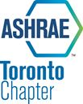
ASHRAE / SMACNA TORONTO

EXPOSITION & SEMINAR

Two industry leaders, the Toronto Chapters of ASHRAE and SMACNA have partnered to sponsor an industry exposition and seminar.

We are contacting you offering the opportunity to display a sampling of your product lines at the upcoming ASHRAE / SMACNA Toronto Exposition & Seminar.

This is also an excellent opportunity for contractors to get their name in front of the engineering community by taking a table to display literature promoting their firm and its capabilities.

The exposition is scheduled for Monday, November 2, 2015 at the Sheraton Parkway North Hotel situated a Hwy 7 and Leslie street. Expo times will be 4:00 pm – 6:00 pm with the opportunity to commence set-up after 1:00 pm on the day of the expo.

The table top expo will be held in the hotel’s Richmond Room and will be complimented with three food stations and a cash bar.

Also in place will be an expo passport which will display each booth holders name with an area for stamping. These passports will be will be submitted to the show executive and all passports which display one hundred percent booth visitation will be eligible for a prize draw.

Following the expo there will be two short industry related seminars in an adjacent room.

EXPO Table Rental: ASHRAE or SMACNA/TSM Members $300
Non Members $400

All display table registrations will be handled through the ASHRAE Toronto Chapter at http://torontoashrae.com/event-2041138

The number of expo tables are limited so contact ASHRAE now to ensure you do not miss this inexpensive opportunity to have you products and firms directly in front of the engineering community associated with the heating, refrigeration and air conditioning industry as well are the contractors associated with this industry.

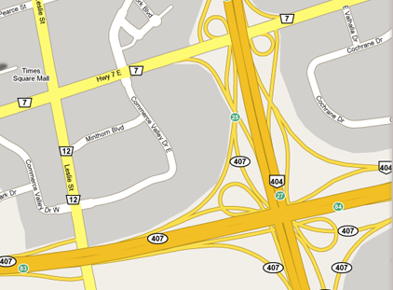

X

All proceeds raised goes to ASHRAE RESEARCH CANADA

